Printing Antigen Barcoded Labels

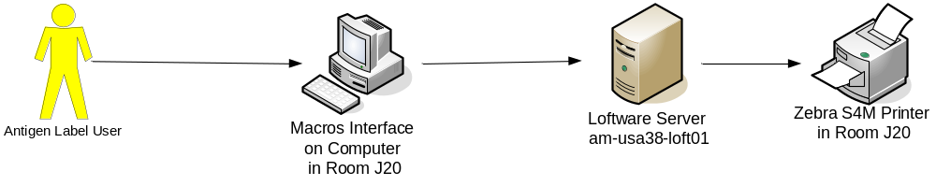

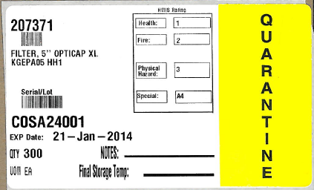
- Open the “Antigen Label Creator.xls” file on the computer desk top

Note: When opening the file for the first time, you will receive the following error message:

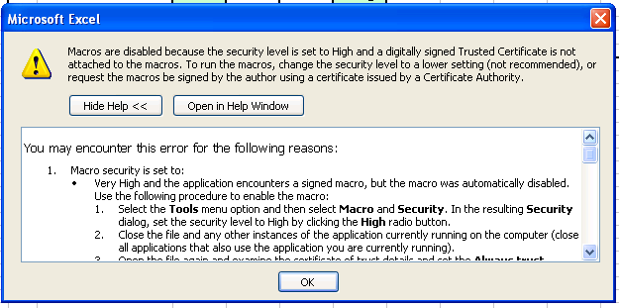
- Click Ok
- Go to Tools → Macro → Security and change the security to “Medium”

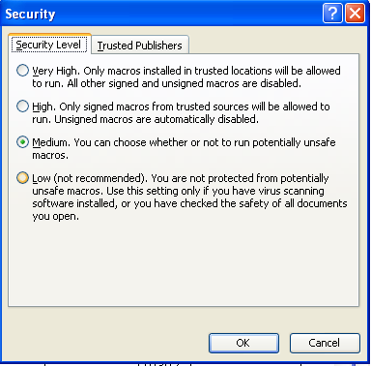

- Click Ok
- Close Excel and reopen the Antigen Label Creator

- Open the “Antigen Label Creator.xls” file on the computer desk top

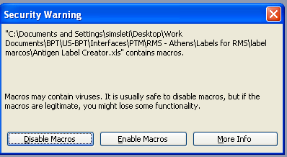

- Click “Enable Macros” when the Security Warning box appears.

(NOTE: this will only appear if the file is closed and re-opened. If the file is kept open, you will not have to do this each time the file is used.)

- The following screen appears:
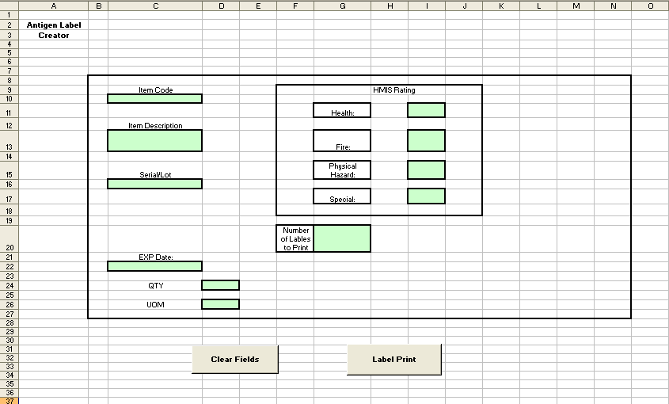

- Enter your data in the green boxes under the following titles:
- Item Code
- Item Description
- Serial / Lot
- EXP Date (NOTE: the lot expiration date will convert to “dd-mmm-yyyy” format)
- QTY
- UOM (NOTE: Choose the UOM from the list of values provided. Click on the UOM box and an arrow will appear. Scroll through the list of UOM values to find the one you want)

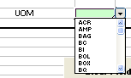

- HMIS Rating: Health (not mandatory, entered only if known)
- HMIS Rating: Fire (not mandatory, entered only if known)
- HMIS Rating: Physical Hazard (not mandatory, entered only if known)
- HMIS Rating: Special (not mandatory, entered only if known)

  - Enter the number of labels to be printed
  - Click out of the “Number of Labels to Print” box

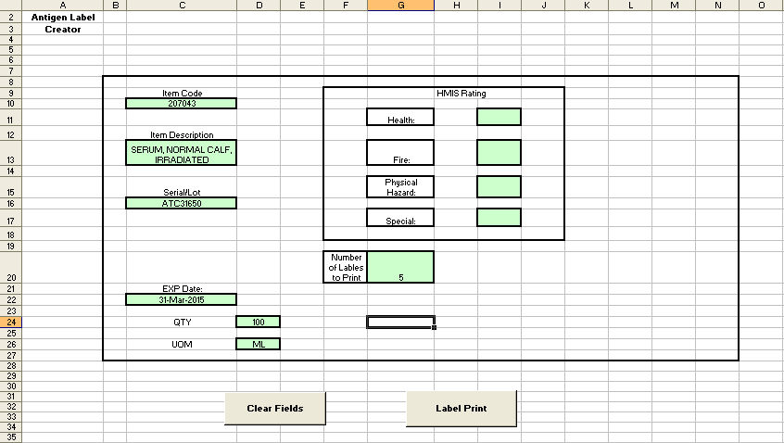
  - Click “Label Print” button
  - The following screen will return

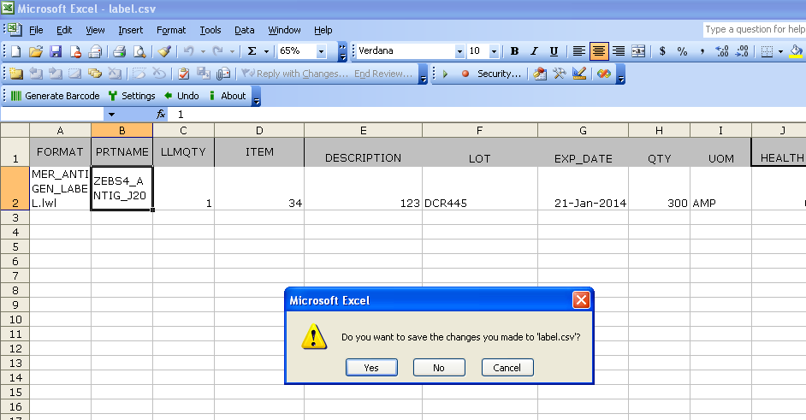

  - Choose either “Yes” or “No” and the label request will be sent.
  - The labels requested will print from the new Zebra S4M printer located next to the computer.

